6.07.2005

episode iii, the backstroke of the west
i saw revenge of the sith last weekend at a local theater with my friend joe who was in town on business. it was much better than the first two movies and a fitting end (err.. middle) to the star wars saga.
the next day i was walking past my friendly dvd salesperson and decided to check out revenge of the sith. i was assured the quality was good and for 7rmb why not give it a shot.
aside from the counters on the top of the screen and a distorted perspective it was ok- not high quality but watchable. the captions were a hilarious surprise- a direct english translation of the chinese interpretation of what the script was saying. it varied from being somewhat close to the script to being 'far far away'....
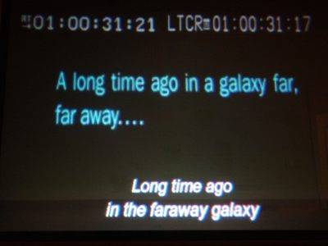
amazingly enough, the beginning scroll is mistranslated even though the words are right there on the screen.
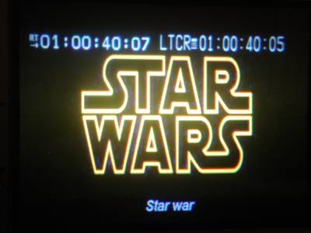
star war (just one)
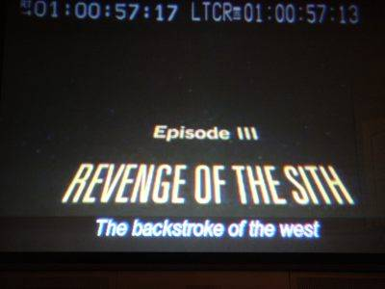
'the backstroke of the west' is the english translation of the chinese title.
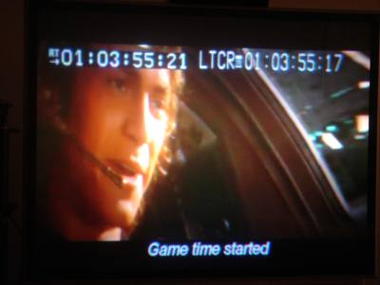
anakin: "this is where the fun begins"
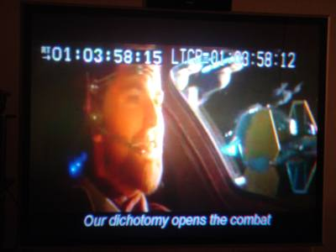
obi wan: "let them pass between us"
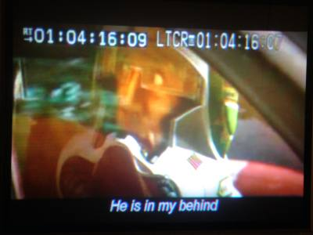
anonymous doomed fighter pilot: "they're all over me"
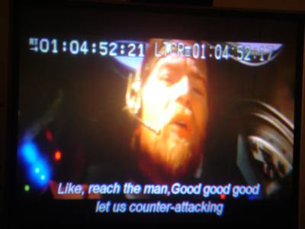
obi wan, space battle strategist.
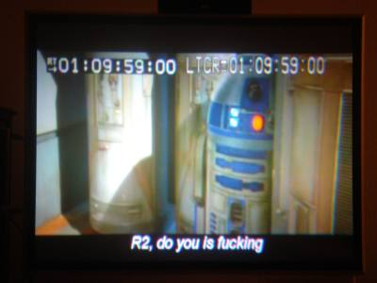
obi wan grows impatient with r2.
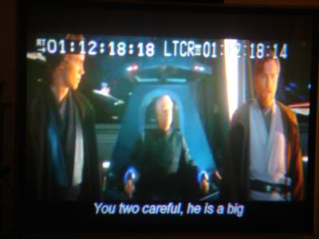
the chancellor warns anakin and obi wan that count dooku is... big.
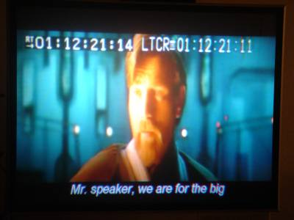
obi wan assures the chancellor that it's no problem.
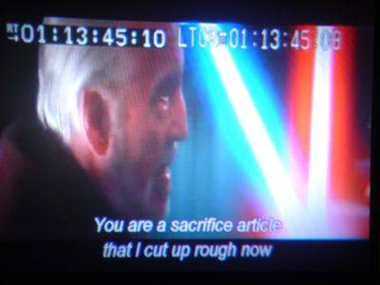
count dooku talks tough.
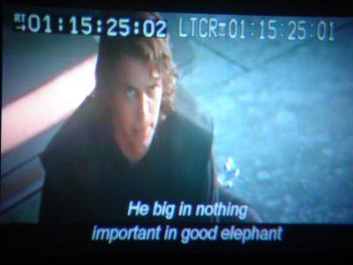
that's chancellor palpatine speaking, talking about obi wan.
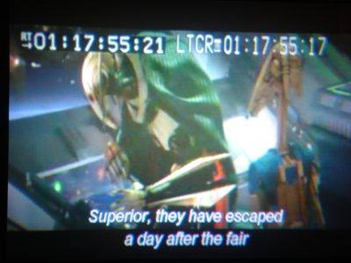
general grevious gets some bad news.
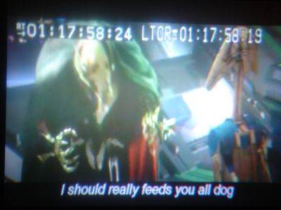
the general considers punishing his troops.
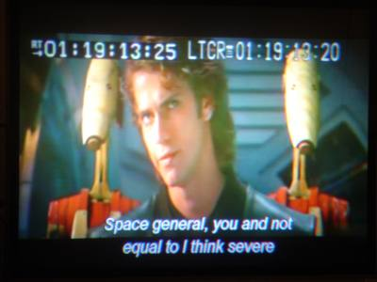
anakin taunts general grevious.
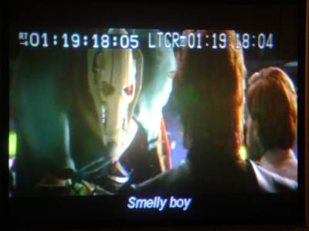
the general fires off a snappy comeback.
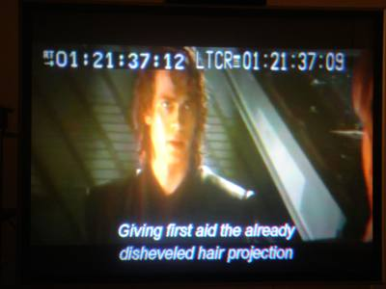
ummm... ????
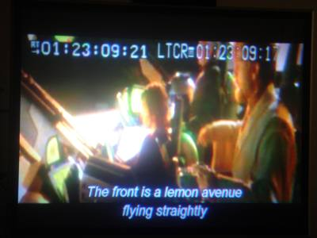
we gonna rock down to... lemon avenue.
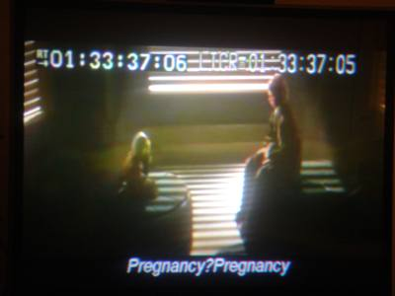
yoda: "premonitions? premonitions?"
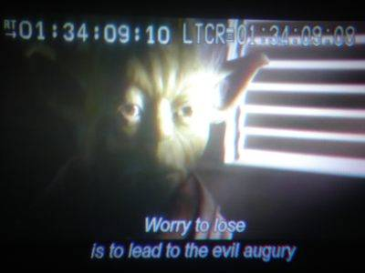
sounds like something yoda might actually say... maybe.
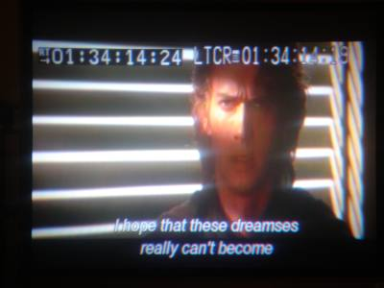
anakin is haunted by dreamses.
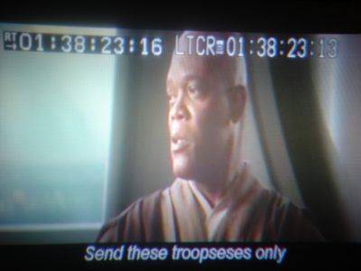
troopseses!
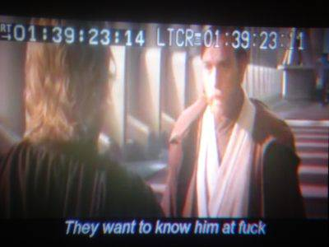
anakin gets frustrated with the jedi council.
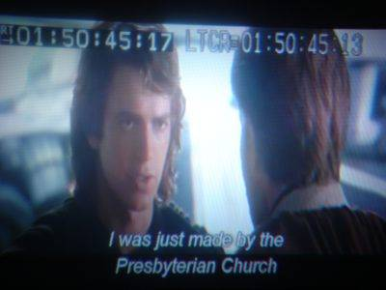
this seemed completely random until i figured out that 'jedi council' was being translated into chinese then back to english as 'the presbyterian church'.
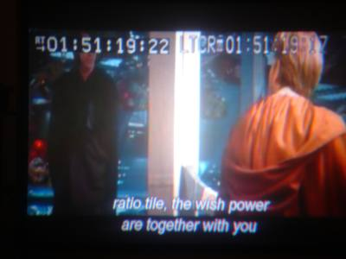
anakin: "obi wan, may the force be with you"
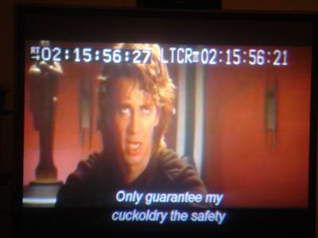
anakin bargains for the life of his cuckoldry. cuckoldry?
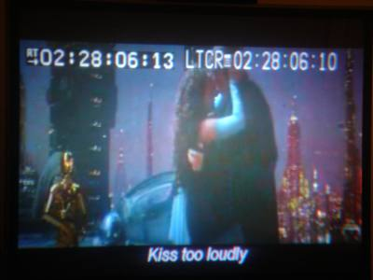
c3po tells the amorous couple to get a room.
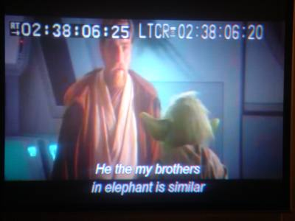
obi wan can't face what he must do.
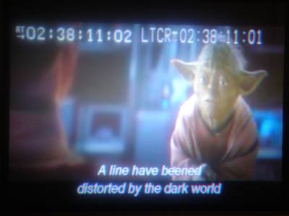
yoda insists...
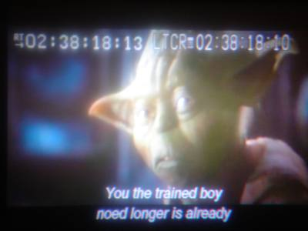
...and explains that the person he once knew noed longer is.
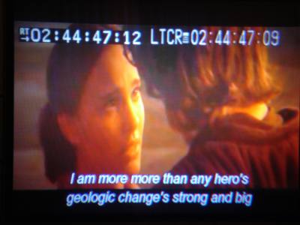
anakin tells padme about his new virtues, now being both strong and big.
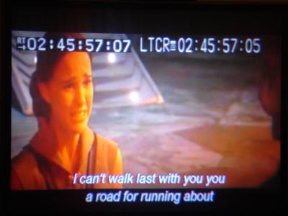
padme doesn't want strong and big- she also doesn't want to walk on a road meant for running about.
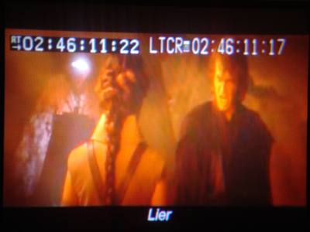
lier!!!
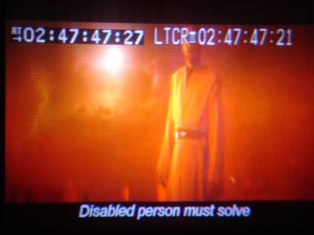
obi wan has heard enough.
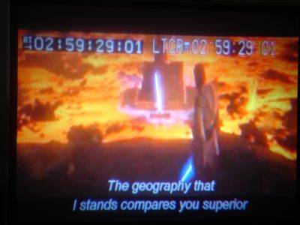
i won't post any spoiler screen shots for those who haven't seen the movie yet- this is a memorable scene towards the end of the film. needless to say, obi wan wasn't actually speaking like yoda in this scene.
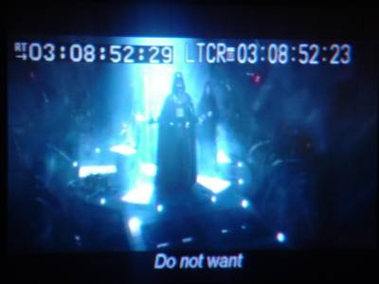
i love this translation. darth vader is actually shouting, "nooooooooooooo..."
captions there be, mangled they are.

